The material is ANSI 321 Stainless Steel Sheet. Steel was chosen over aluminum due to maintaining a higher yield strength at high temperatures. See <https://burnsstainless.com/blogs/articles-1/yield-strength>

Engine is designed around the specifications of Raptor V3 with a gimbal. Weighs slightly more. The red parts are hydraulic actuators for thrust vector control. One of the orthogonal actuators is for the x position, while the other is for the y position. Three engines are used as this would allow rocket control in all 6 degrees of freedom with appropriate control.

The nose cone is a ¾ parabolic nose cone. As the nose is pointing upwards during landing, this has minimal aerodynamic impacts for our simulation. The change is to more realistically model a rocket that was to go through both launch and landing. The ¾ parabolic nose cone offers the best supersonic flight drag coefficient, but suffers with heat issues during hypersonic flight.

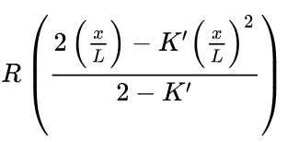K’ = ¾ L=300 R= 180 for Nose Cone

